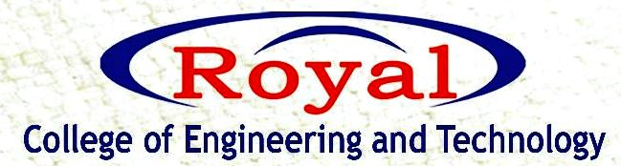
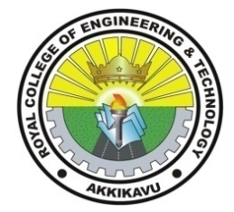
IEDC
“IDEA PITCHING CONTEST 2021”

RCET IEDC conducted an “Idea Pitching Contest” on 01/12/21 wednesday.
The students’ presentation started at 10 am. 42 students registered for the event among them 32 students participated after departmental scrutiny from various branches including EC, EEE, CSE and ME .
Judging pannel included Mr Abu KA, Mr Praveen KP and Mr Yassir Moidutty. Valuable suggestions from Mr Leo Mathew were an added advantage for the students.
The event was coordinated by Ms Sruthy Menon under the guidance of Mr Dinto Thomas. Dr Kiran KP and Ms Neethu was also present during the event.
All the presentations were informative and judges enhanced the quality of the program by discussing their views and interacting with students. The presentations and judgment came to an end by 12.30 pm.

